Programmer: Jeremy Sun
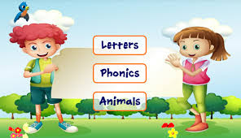 ICS201 - Final Evaluation 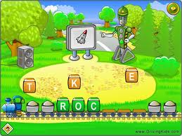

Final Project Proposal and Algorithm

Instructions:

The task for today is to complete the initial stages of the final programming assignment for this course. Copy this file to your own hand in folder and complete the sections given below, save and submit to the hand in folder of your account. Wait for further instructions when you are done. This task is due by the end of the period.

Programmer: Jeremy Sun Assigned: Jan 9 and Due: Jan 10, 2017

Current level in programming: 3 to 4_________ (as indicated by your teacher)

Level Attempting: 4 (as mutually agreed upon by you and teacher)

Part A: Title and Description of Project undertaken
For those attempting levels 2-4 note the branding that we discussed for your finished product.

Title of Program: Kampf Gruppe Steiner Education

Description of the program: (what the program intends to accomplish and how it will be useful):
(be specific and provide adequate details for user to make an informed purchase)

A Math and English quiz show that entertains and educates students of Grades 1 -4. Students learn through constant repetition, interactive games, and a variety of quizzes on different subjects. Interactive lessons will introduce and reinforce concepts both old and new. Along with core units, additional units can be unlocked through gameplay to enhance the child’s learning. Easter eggs included!

Part B: Write and draw a detailed flowchart for the program you will be coding. When done save this whole document to the hand in folder.

Flow Chart for Lvl 3 was submitted by hand.

You will not be allowed to program until you hand in your Algorithm to your teacher.

When done, submit this document to the hand-in folder of your account and notify your teacher.

All Programming files for this final evaluation will be saved in the hand in folder. You can keep a backup in the H drive of your account.

